**HEMANG** BHAVASAR

*AVP – Lead Tableau Architect*

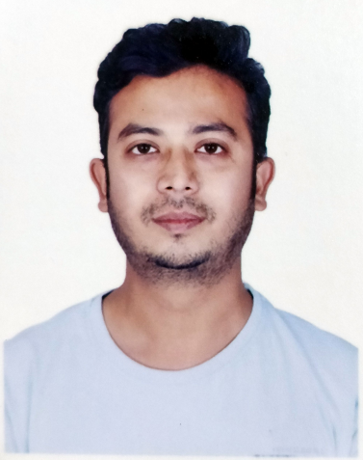

Summary

* **11+** years of hands-on expertise on BI Tool
* **Knowledge** of toogls such as Google Cloud AI, Dialogflow, Looker, Data Studio, Tensorflow, Google Cloud and Azure
* **Domain expertise** spans across industries, including finance, healthcare, marketing, e-commerce, and more
* **Winner** of the first ever worldwide hackathon organized by Tableau
* Accomplished **483 Global Rank** in Two Sigma's Halite III open-source AI challenge. More than 5 million Halite III games were played by bots over the course of 3 months
* Designed **voice & motions enabled** Tableau dashboards using JavaScript
* Created **Tableau Server data model** using Tableau PostgreSQL tables
* Expertise in **performance improvement**, and shaping data in Tableau
* Solved complex scenarios as a member of **Tableau COE** team in the organizations. Along with mentored team members and client level, resulting in 38% average growth in their performance
* Awarded by Rajasthan Government to achieve **AIR 478** in GATE-2008 exam

About Me

I am a highly qualified and results-driven data analyst with over 11+ years of experience in multiple domains. I have a track record of using data to provide actionable insights and improve business performance.

I am skilled at interpreting complicated data sets and turning them into useful suggestions since I have a solid grasp of statistical analysis, data visualization, and data management. I'm a detail-oriented, analytical expert with experience with Tableau, Power BI, Alteryx, and Cloud Platforms.

I also have a strong ability to interact with both technical and non-technical stakeholders.

   

Education

**Dr. B. R. Ambedkar NIT Jalandhar, Punjab**  
*Post Graduated*  
Master of Technology

2009 – 2011

**University of Rajasthan, Jaipur**

*Graduated*

Bachelor of Engineering  
2004 - 2008

Skills

**Technical Skills**

#Tableau #TableauServer

 

#PowerBI #Alteryx

 

#DataStudio #TableauPrep

 

#Python #R

 

**Personal Skills**

Creativity Analytical

Time Management Communication

Teamwork Leadership



Contact Info

Pune, Maharashtra

+91-9987609997

bhavasarhemang@gmail.com

https://github.com/hemangbhavasar

twitter.com/bhavasarhemang

linkedin.com/in/hemangbhavasar

https://public.tableau.com/profile/hemang

.bhavasar







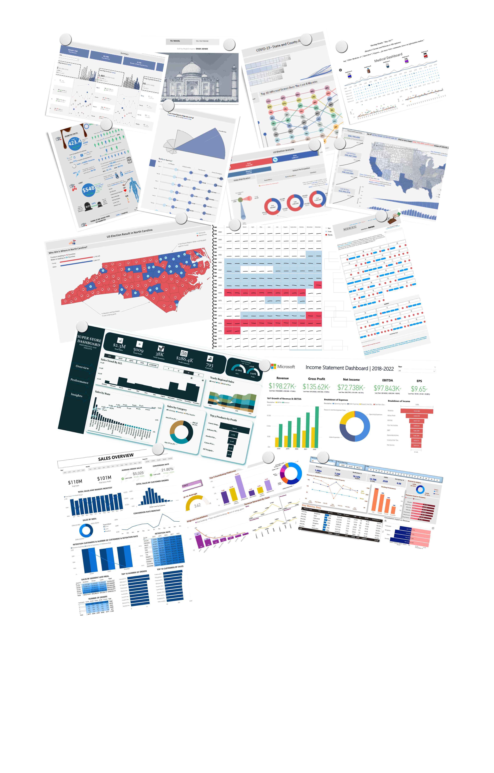

Stats

**Awards Appreciations Projects Certification**

**9 56 14 16**

**Clients Served RFP POC Given Training**

**11 18 27 13**

Experience

**Credit Suisse – AVP (Lead Tableau Architect);** Pune, Maharashtra Jun 2021 – Present • 1 Year 9 Months

* Asset Quality Monitor designed for Prime Financing Swaps Trading Desk to provide a single of complete business by providing insightful KPIs such as collateral rating specific Exposures , mitigation, commission and an easy view to spot a breach on defined thresholds.
* Dashboards which allow business desk to monitor client performance at specific timeframe and allow business users to view the position at most granular level (i.e. RIC) for each clients.
* Develop Data Driven Solutions. Ability to understand the business, develop data-driven solutions to address business problems and independently manage end-to-end project communication with business partners.

**Altimetrik Pvt Ltd – Technical Lead (Data Engineering);** Pune, Maharashtra Jun 2021 - Sep 2021 • 4 Months

* Established a model that increased sales revenue by 12.7% in the EMEA region by examining a database of customers' past purchases in comparison to their present demands to identify sales possibilities. (Equating to 27.4% of the business's revenue)
* Supervised a group of 3 data scientists and 2 data Analyst to model the ordering procedure in 5 different ways, present the results, and offer suggestions to boost order output by 9%.

**Saama Technologies – Lead Data Analyst;** Pune, Maharashtra Feb 2015 - Jun 2021 • 6 Years 5 Months

* Built 70+ scalable dashboards and custom reports on Financial Analytics by processing high volume of real-time data.
* Developed model to reducing the expense on Tableau licenses by 30%.
* Achieved a performance score of 97.3% incident free for quick and accurate root cause analysis.
* Independently created 4 applications for auditing reports. The team's project delivery rate rose by 31% as a result of using these tools.
* Increased customer satisfaction by 28% while reducing analytical work by 37% by using automated data scraping, wrangling, and data loading for internal applications.
* Build over 36+ Extract-Transform-Load jobs to retrieve data from Postgres database to Oracle database and further load this data into clustered Azure SQL database after imputation and structural transformations using Alteryx/Tableau Perp.
* A GUI tool that provides documentation for Tableau workbooks was developed, which resulted in a 62% reduction in the average document generation time.

**Mastek Ltd – Software Engineer;** Navi Mumbai, Maharashtra Aug 2014 - Feb 2015 • 7 Months

* Created a random forest customer attrition model that, by giving customers who were inclined to opt-out useful product features, increased monthly retention by 12 basis points.
* Contributed to design and set-up of Tableau ecosystems used by management and sales department for Provided market analysis.

**Capgemini India – Consultant;** Mumbai, Maharashtra Sep 2011 - Aug 2014 • 3 Years

* Recognizing immediate and long-term problems and suggesting solutions helped sales engineering be more effective, which led to a 4.4% increase in sales.
* Performed in-depth analysis and identified lack of an operations function as area of improvement; implementation of proper performance improvement factor which decreased a refreshing time of report by 39%, resulting in 12-13 minute in time-savings.
* Shortened Tableau migration lifecycle by an average of 32 days, improved working capital position by 7% for Q4 FY13.

Interests





Published Paper

**Mems Nano;** IEEE InternationalFeb 2011

**Blood Batteries;** IEEE National PapersMar 2010

**Photonic Communication Through MICROMIRRORS Based On MEMS Technology;** IEEE National PapersAug 2010

**Application Of Dusty Plasmas For Space;** NASA Research Papers Apr 2010

Portfolio